Let T: R^2 → R^2 be a linear transformation such that T(u)= [1 2]^T , T(v) = [-1 0]^T for given u, v E R^2. Find T(2u-3v).

(iv) [5 4]^T.

Which of the following statements are true for every 4 x 4 matrix A:

(i) det (-A)=-det A

(ii) det (2A)=16 det A

A. Both (1) and (ii) are true

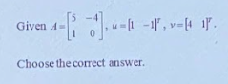

© None of the other choices is correct.

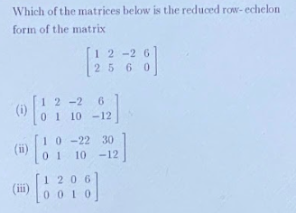

 (ii) [[1, 0, -22, 30], [0, 1, 10, -12]].

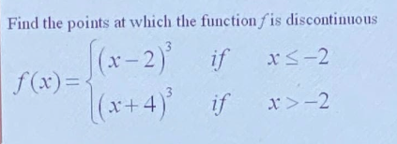

1. None of others



1. -14

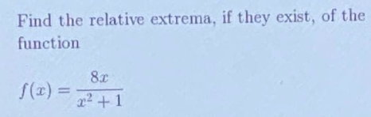

Relative minimum at (-1, -4), relative maximum at (1, 4).

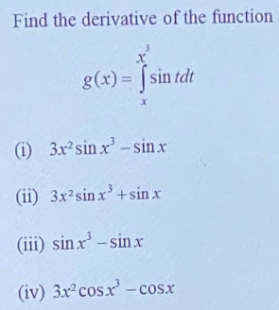

1. 

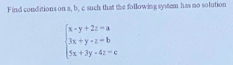

[C: b - 2c + a is not 0](https://www.khanacademy.org/math/algebra-home/alg-system-of-equations/alg-systems-with-three-variables/v/solutions-to-three-variable-system-2" \t "https://edgeservices.bing.com/edgesvc/_blank)

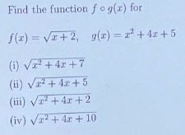

1. : .



 t = 3 and t = 5

None of the choices is correct